

Finding and Downloading Landsat Data
from the U.S. Geological Survey’s
Global Visualization Viewer Website

All Landsat data are available to the public at no cost from U.S. Geological Survey (USGS) websites. Among these are Global Visualization Viewer (GloVIS): http://glovis.usgs.gov
and LandsatLook: LandsatLook.usgs.gov
This tutorial describes how to get data from GloVIS.

Before you begin, please note:
Landsat scenes are large files. Unzipped Landsat 5 scenes are about 404 megabytes (MB), and Landsat 7 scenes are about 654 MB. This is an important consideration when downloading or manipulating them1

SUMMARY
STEP 1. Register as a user of USGS data and create an account.
STEP 2. Log in (after registering).
STEP 3. Go to the USGS GloVIS website.
STEP 4: Select a satellite collection.
STEP 5. Find your scene of interest by clicking on the interactive map.
STEP 6. Add desired scenes to your list.
STEP 7. Order the scene(s) you have selected.
STEP 8. Uncompress the files (twice).

Core Concept
Landsat scenes are made of several files or layers (bands) of data. Each band represents a section of the electromagnetic spectrum that has been selected because it is useful for distinguishing kinds of land cover and land use from one another, and measuring ways they change over time.

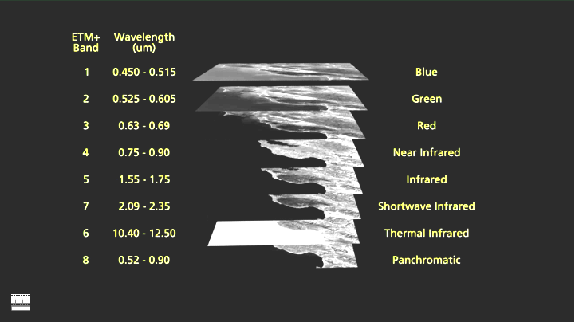
Landsat 7 scenes include visible and infrared wavelength ranges.
Before you use this tutorial
Please be aware that few websites remain exactly the same for long, and the USGS GloVIS website is no exception. The agency modifies its websites as time passes. So you may encounter slightly different screens or directions from those in this tutorial. If you have a question or need assistance, you can click on the “Contact USGS” link at upper right of the GloVIS page.

STEP 1. Register as a user of USGS data and create an account.
To be able to download data from either GloVIS or Earth Explorer sites, you must first register and create an account.

To register and create an account, go here:
https://earthexplorer.usgs.gov/register/?return

TIP: Be sure to prior to starting your search for Landsat scenes on GloVIS as the system will not let you download any data unless you are logged in!
Screen 1 of a 4-screen login/registration process appears below.

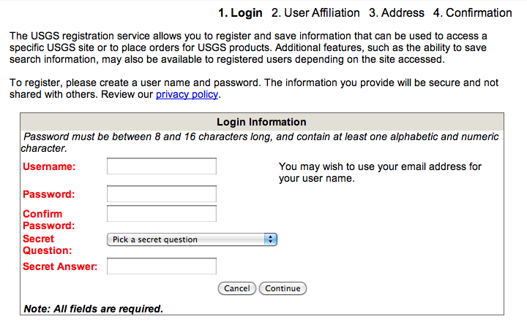
↓
STEP 2. Log in (after registering).

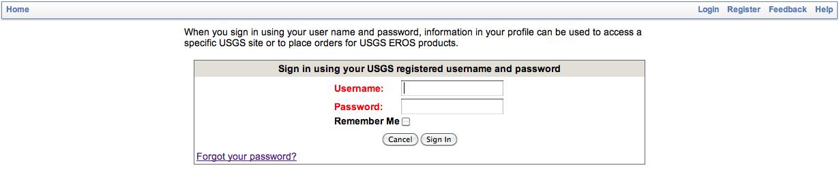

The system may automatically take you to Earth Explorer when you log in. Go rather to the GloVIS website. See Step 3.

STEP 3. Go to the USGS GloVIS website: http://glovis.usgs.gov
Make sure that –
- Your pop-up blockers are off.
- Java is enabled.
- Your software is updated. See “System Notices” on the GloVIS site.

A window may appear in which you are asked if you want to run the USGS viewer.
Choose “Run.”
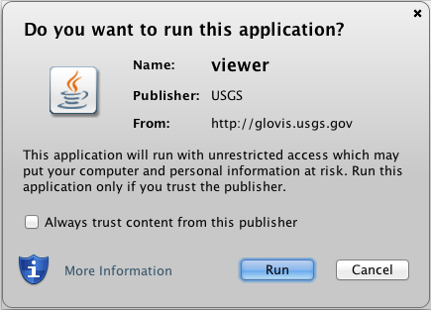

When you first open GloVIS, you will see a screen like the one below.

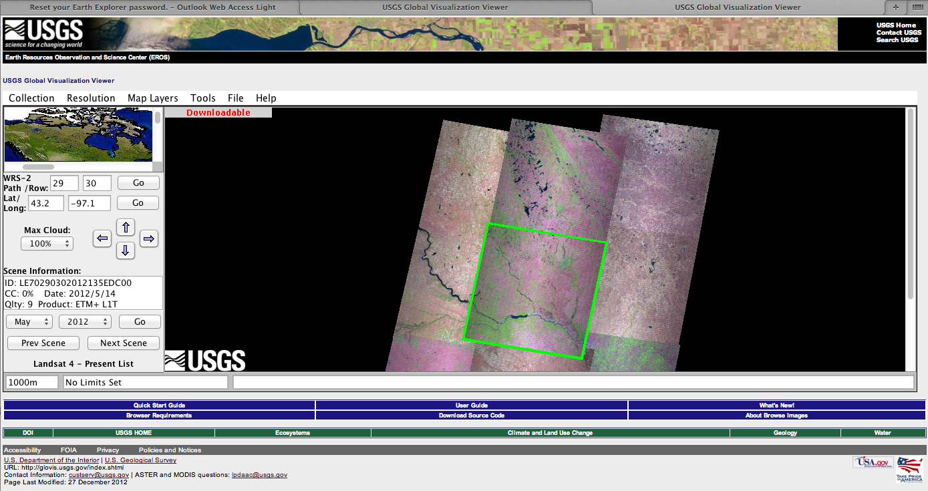

The page includes a map at upper left (under “Collection” and “Resolution.”)
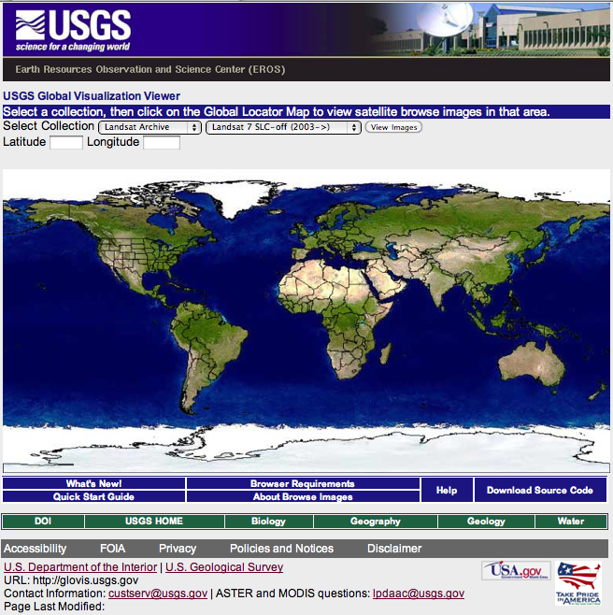

STEP 4: Select a satellite collection.
Above the map, see “Collection.” Pull that menu down; choose “Landsat Archive” and, next to it, “Landsat 4-7 Combined.”

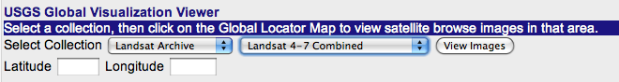
↑

TIPS
a. Available data includes the entire archive dating back to 1972. The data for best comparability with current dates and best data quality begins with Landsat 5 in 1984.

b. In order to get to the first three Landsat satellite’s data you will need to navigate to “Collection” at the top of the application, then to “Landsat Archive” and finally to “Landsat 1-3,” and select it. The data from Landsats 1-3 extend from 1972 to 1982. Note however, that the scenes are smaller and the image quality may not be as consistently good as newer Landsat scenes.

NOTE: The following guidelines apply only to the Landsat 4-7 portion of the data archive, not to Landsat scenes taken before 1984.

STEP 5. Find your scene of interest by clicking on the interactive map.

There is a Landsat scene that covers every location on Earth between ~82° N and S. Each Landsat scene covers a region approximately 182 km x 185 km (113 x 115 miles).

This window may appear:
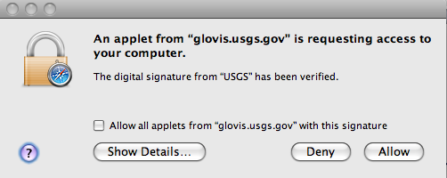
Click on “Allow.”

TIP
You may wish to turn on city names in “Map Layers” (near top) in order to help locate your scene of interest.

The example in this tutorial uses part of a peninsula on the east coast of the United States called the Delmarva Peninsula. (“Del-mar-va” refers to Delaware, Maryland, and Virginia.)

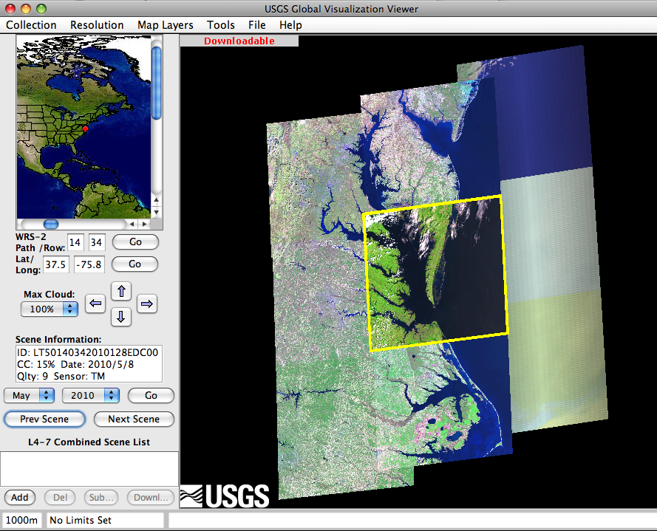

To help find the scene of interest, you can select the "Map Layers" menu on the menu bar. You will then be able to view administrative boundaries, country boundaries, the collection grid, roads, water, north arrow, and/or World Cities (and others).

You can also use latitude and longitude. Lat/long can be found by an Internet search if needed.

You can choose to view scenes from other dates by changing the month or year and clicking on “Go,” or by clicking on “Prev Scene” or “Next Scene.”

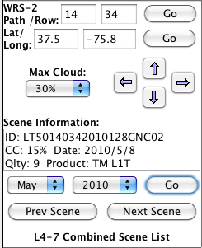
WRS-2: Worldwide Reference System (WRS) refers to the global notation for Landsat data. See “path/row” below.

Path/Row: As the spacecraft moves along its path, the sensor scans the terrain below. A grid system of paths and rows (the WRS) is used to provide a reference number for each scene. In the case of this particular scene, the path is 14, and the row is 34.

Lat/Long: Each path and row grid can be identified by its latitude and longitude as well as by its path and row.

Max Cloud: Landsat sensors do not see through clouds. You can choose what percentage of a scene you are willing to have covered by clouds. If you choose “30%,” the GloVIS search function will show you only scenes with 30% or less cloud coverage.

Scene Information: Example: LT50140342010128EDC00

Don’t worry too much about this Scene Information ID number!

You DO need to know that –
The third character in the Scene Information ID number tells you which satellite acquired the scene.
So in this case, “LT5” indicates that the scene was acquired by the Landsat 5 satellite (not Landsat 4 or Landsat 7).

Optional: More about Scene Information

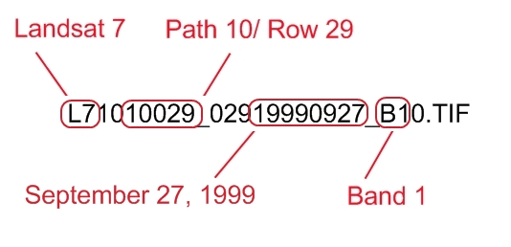

CC: Cloud cover. 15% means clouds cover 15 % of the scene. Landsat sensors cannot see through clouds. The closer to 0% this is, the better. So choose “30%” here.

Date: This is the date when the scene was acquired: year/month/day – So in the case of the example here, 2010 is the year; 5 is the month (May); and 8 is the day.

Qlty: 9: Quality ranges from 0-9 with 9 being the best.

Sensor: This tells you what instrument on the satellite acquired the image. If it says "TM" it refers to Landsat 4 or 5’s Thematic Mapper. If it says "ETM+" it refers to Landsat 7’s Enhanced Thematic Mapper Plus.

Note about Striping. Landsat 7’s sensor developed a problem in May 2003 that causes striping from a lack of data on both sides of the scene–though not in the middle. USGS has data products to deal with that. But for this introductory level, unless the area you want to study is in the center of the scene, you will want to use only Landsat 7 scenes taken before May 30, 2003, and any Landsat 5 scenes.
(Landsat 5’s sensor does not have this striping problem.)

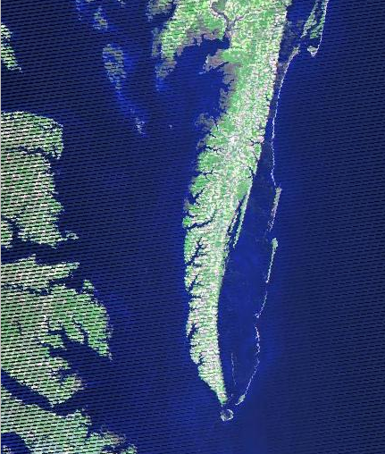
See stripes in this Landsat 7 image where data are missing from both sides. In late May 2003, the ETM+ instrument’s Scan Line Corrector (SLC) failed. “SLC-off” indicates scenes including that failure, all Landsat 7 scenes after May 30, 2003.

The word, “Downloadable” may appear in red in the upper left-hand corner of the scene itself. That usually – but not always – means you can download the scene right away without having to order it from USGS (and waiting for it).

Resolution. If you click on “Resolution,” near top of screen, you will see a drop-down menu that offers both 1000 m and 240 m resolution. Toggle back and forth and see what changes.

STEP 6. Add desired scenes to your list.

(a) For each scene you think you might want, make sure it is selected within the yellow box, then click “Add,” near lower left of screen. That scene number will appear in a box below called, “Landsat 4-7 Combined Scene List.”
→ 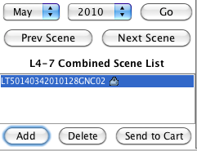

Deleting scenes from your list:
If you decide you don’t want a given scene after all, you can click on it and then on “Del” or “Delete” to remove it from your list.

To download a scene, see that it is selected within the yellow highlighted box, then click “Add” at the lower left hand corner of the screen.

Tip
If you can’t see the window called, “Landsat 4-7 Combined Scene List,” go to “View,” pull down and choose, “Actual Size.”

(b) Click on “Send to Cart.”

→ If “Downloadable” appears in red font, in the upper left corner of the image, you can get it right away. Go to Step 7.

→ If “Downloadable” does NOT appear on the upper left-hand corner of the scene, go to Step 7 (d) below. You will need to order it. Getting your ordered scene will take one or two business days.

STEP 7. Download or order the scene(s) you have selected.

TIP
Time to download: Landsat scenes are large files, up to 800 Mb, and may take a long time to download.

(a) Clicking on “Send to cart” (in Step 6) will pop up a new window with the scene information.
Click “Bulk Download.”

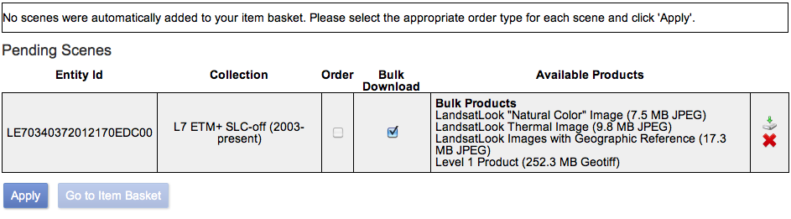

Clicking on the red X to the far right of that screen will delete the scene from your order.

(b) Click on the green download arrow just above the red X.
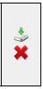

The Download Options window will appear.
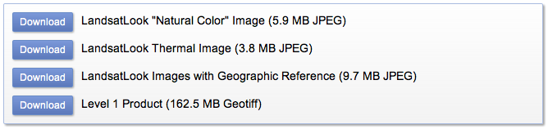

(c) Choose the data product you want to download, and click on that “Download” button.

If all you require is a natural color image (one that looks like you might take it from a simple camera in space) select the LandsatLook “Natural Color” Image and finish by clicking the “Select Download Option.”

LandsatLook Images
LandsatLook images are full resolution ready-made Landsat images. More specifically, they are JPEG files derived from Landsat Level 1 data products. They are available as pseudo-natural color images or as thermal grey-scale images. The images are compressed and stretched to create an image optimized for image selection and visual interpretation. LandsatLook images are very useful if you want a full-resolution image, but if you do not want to download the full data set and make a composite RGB image yourself.

If you want to composite your own image, selecting wavelength of your choice, you need all data layers in your scenes. Select the last option in the Download Options menu, Level 1 Product. The other two menu options are self-explanatory.
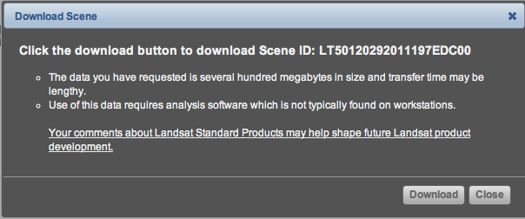

Remember, you can download the full image data right away only if the screen says Downloadable in red at the top. If it does not so appear, you can still submit the order, and expect to wait for a period of up to a week.

(d) If “Downloadable” does NOT appear on the upper left-hand corner of the scene, that scene is not immediately downloadable. After you click on “Send to cart” in Step 6, you will see a window like the one below.

- Click on “Apply.”
- Click on “Go to item basket.”
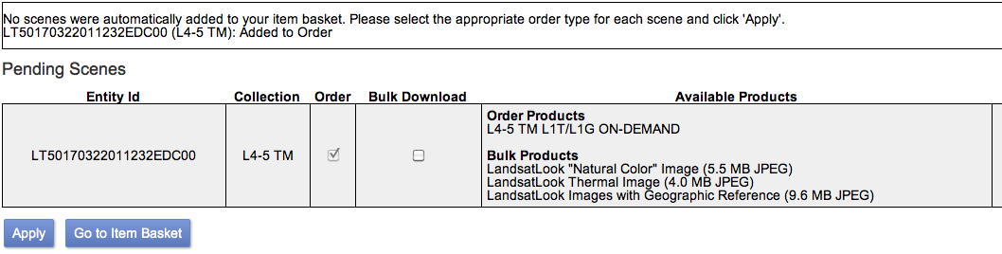

3. Click on “Proceed to check out” in the window like the one below.

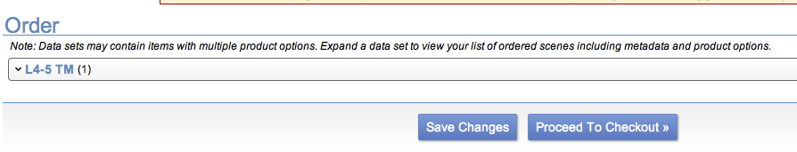

4. Click on “Submit order.” When the data are ready (in a matter of days) you will receive an e-mail message from the U.S. Geological Survey indicated how to retrieve it.

STEP 8. Uncompress the files – twice! – using zip software.

The files will be compressed, so uncompress them using zip software. Unzip twice!

Tip
Several software packages exist for this purpose and can be found by a Web search.

Your unzipped folder contents will look something like this:

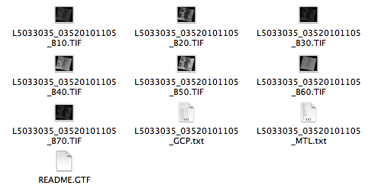

Each of the files whose name ends in “TIF” holds the data from one Landsat band.

Remember the Core Concept: Landsat scenes are made of several files or layers (bands) of data. Each band represents a section of the electromagnetic spectrum that has been selected because it is useful for distinguishing kinds of land cover and land use from one another, and measuring ways they change over time.

To make Landsat images from these downloaded data files in band combinations of your choice, see a separate tutorial, “Making Landsat Images Using ImageJ,” or, “Making Landsat Images Using Photoshop.”

To learn more about Landsat scenes, study one or more of these tutorials:
An Introductory Landsat Tutorial
http://zulu.ssc.nasa.gov/mrsid/tutorial/Landsat%20Tutorial-V1.html

Fundamentals of Remote Sensing
http://www.nrcan.gc.ca/earth-sciences/geography-boundary/remote-sensing/fundamentals/1430

If you are an educator and you have any questions, you may contact –
Jeannie Allen, Sigma Space Corp.
Hydrospheric and Biospheric Sciences
NASA Goddard Space Flight Center
Organization Code 618; US Mail Code 610.9
Greenbelt, MD 20770
E-mail: Jeannette.E.Allen@nasa.gov

